Introduction:

- Tasks requirement

Task A

- Libraries involved

- tensorRT: framework used to run the pre-trained network
- numpy: used to process values, eg. normalization
- opencv: used to convert depth image to RGB, draw out guidance line and display distance
- traitlets: used to display the image on notebook
- widgets: used to display detection on notebook

- Flowcharts for the design and coding

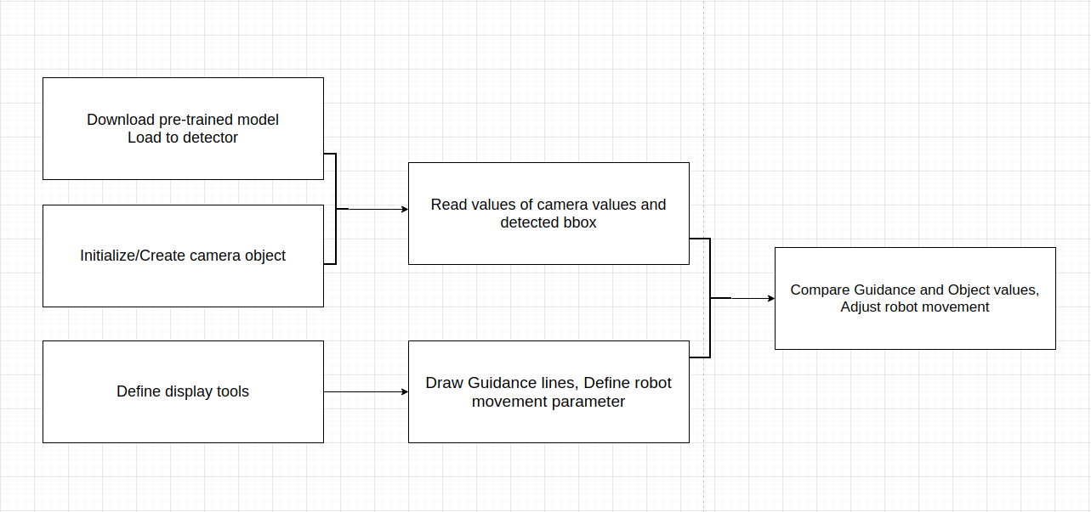

- Design explanation

1. Download pre-trained model, Load to detector
2. Initialize/Create camera object
3. Define display tools
4. Draw Guidance lines (left most?), Define robot movement parameter
5. Read values of camera values and detected bbox (object (xy, centre, distance))
6. Compare Guidance and Object values, Adjust robot movement

- Class
1. ObjectDetector: class used to load pre-trained network into tensorRT framework
2. Camera: Class used to control camera to capture frame and values

- Functions
1. normalize: Normalize guidance lines and bbox values
2. processing: Compare values in frames and guidance line, determine movement of robot
3. draw guidance line:

- Test procedure

- Results
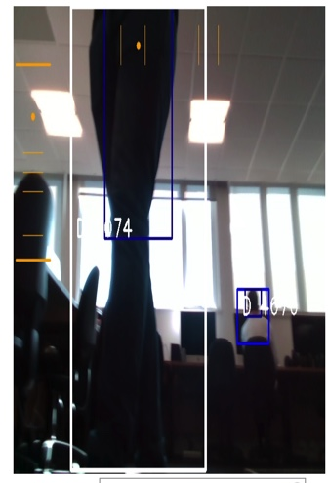

Robot guidelines, distant is on left side of image, movement left/right is on top of image. Guideline lines are boundaries for different speeds of moving forward/back and left/right

- Analysis

Conclusion

-

